Ex.No:5.a | DATA VISUALIZATION USING MATPLOTLIB
Aim:

Algorithm:
Step 1: Start.
Step 2: Import the required libraries:
- pandas
- matplotlib.pyplot
- seaborn (optional)
Step 3: Create the monthly sales dataset or load it from a CSV file.
Step 4: Store the data in a Pandas DataFrame.
Step 5: Display the dataset to verify that it has loaded correctly.
Step 6: Create the required visualizations:
- Line Plot
- Bar Chart
- Scatter Plot
- Histogram
- Box Plot
- Pie Chart
Step 7: Add appropriate:
- Title
- X-axis label
- Y-axis label
- Legend (if needed)
Step 8: Display each graph using plt.show().
Step 9: Analyze the visualizations to identify:
- Sales trends
- Highest sales month
- Lowest sales month
- Distribution of sales values
Program;
import matplotlib.pyplot as plt
months = ["Jan","Feb","Mar","Apr","May","Jun"]
sales = [120,150,180,170,220,250]
plt.plot(months,sales)
plt.title("Monthly Sales")
plt.xlabel("Months")
plt.ylabel("Sales")
plt.show()
Bar chart:
plt.bar(months,sales)
plt.title("Monthly Sales")
plt.xlabel("Months")
plt.ylabel("Sales")
plt.show()
pie Chart:
departments = ["HR","IT","Finance","Sales"]
employees = [25,40,20,15]
plt.pie(employees,
labels=departments,
autopct='%1.1f%%')
plt.show()
Box plot:
salary=[25000,27000,30000,
32000,35000,
40000,150000]
plt.boxplot(salary)
plt.show()
line chart:
months=["Jan","Feb","Mar","Apr"]
sales=[120,150,180,200]
profit=[20,30,40,50]
plt.plot(months,sales,label="Sales")
plt.plot(months,profit,label="Profit")
plt.legend()
plt.show()

Output:
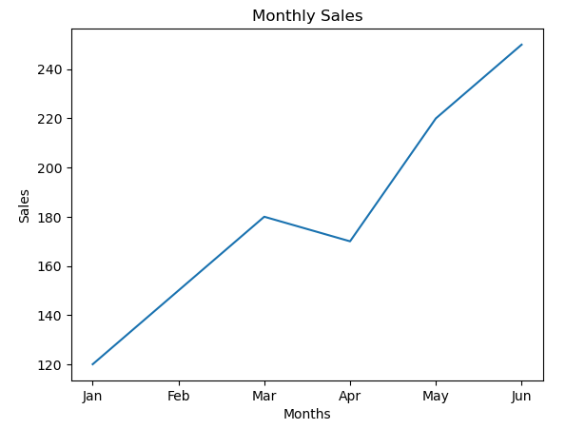
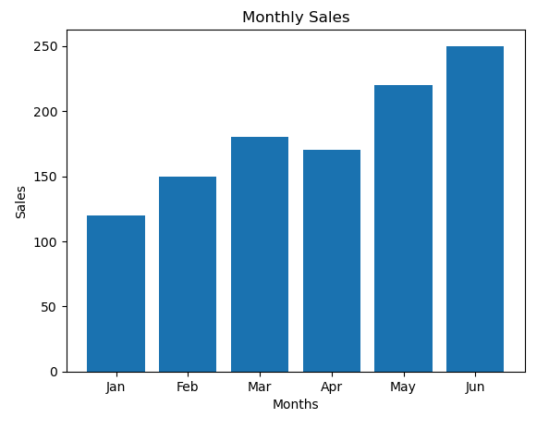
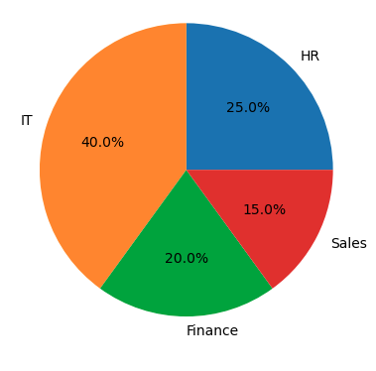
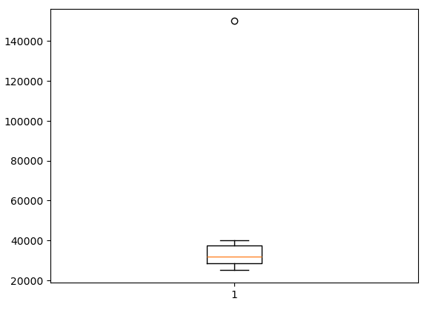
Result: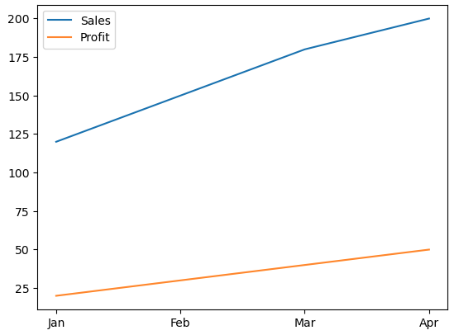

Ex.No:5.b | DATA VISUALIZATION USING MATPLOTLIB

Aim:

Algorithm:
Step 1: Start.
Step 2: Import the required libraries:
- pandas
- matplotlib.pyplot
- seaborn (optional)
Step 3: Create the monthly sales dataset or load it from a CSV file.
Step 4: Store the data in a Pandas DataFrame.
Step 5: Display the dataset to verify that it has loaded correctly.
Step 6: Create the required visualizations:
- Line Plot
- Bar Chart
- Scatter Plot
- Histogram
- Box Plot
- Pie Chart
Step 7: Add appropriate:
- Title
- X-axis label
- Y-axis label
- Legend (if needed)
Step 8: Display each graph using plt.show().
Step 9: Analyze the visualizations to identify

Program:
import pandas as pd
import seaborn as sns
df = pd.read_csv("medical_dataset_1100_rows_v2.csv")
plt.figure(figsize=(8,5))
plt.plot(df["Age"], df["BMI"])
plt.title("Line Plot: Age vs BMI")
plt.xlabel("Age")
plt.ylabel("BMI")
plt.grid(True)
plt.show()
Box plot:
plt.figure(figsize=(6,5))
plt.boxplot(df["BMI"])
plt.title("BMI Box Plot")
plt.ylabel("BMI")
plt.show()
Histrogram:
plt.figure(figsize=(8,5))
plt.hist(df["Age"], bins=15, edgecolor="black")
plt.title("Age Distribution")
plt.xlabel("Age")
plt.ylabel("Frequency")
plt.show()
Violinplot:
plt.figure(figsize=(6,5))
plt.violinplot(df["BMI"])
plt.title("BMI Violin Plot")
plt.ylabel("BMI")
plt.show()
plt Plot:
plt.figure(figsize=(10,5))
plt.plot(df.index, df["Blood_Sugar"], color="red")
plt.title("Blood Sugar Trend")
plt.xlabel("Patient Record")
plt.ylabel("Blood Sugar")
plt.grid(True)
plt.show()
Stackplot:
plt.figure(figsize=(10,5))
plt.stackplot(
df["Patient_ID"],
df["Height_cm"],
df["Weight_kg"],
labels=["Height", "Weight"]
)
plt.title("Height and Weight")
plt.xlabel("Patient ID")
plt.ylabel("Values")
plt.legend()
plt.show()
Rotation:
plt.figure(figsize=(12,5))
plt.plot(df["Patient_ID"], df["BMI"])
plt.xticks(rotation=45)
plt.title("BMI by Patient ID")
plt.xlabel("Patient ID")
plt.ylabel("BMI")
plt.tight_layout()
plt.show()
Pie chart:
disease = df["Disease"].value_counts()

plt.figure(figsize=(7,7))
plt.pie(disease,
labels=disease.index,
autopct="%1.1f%%",
startangle=90)
plt.title("Disease Distribution")
plt.show()
fig, ax = plt.subplots(2,2, figsize=(12,8))

ax[0,0].plot(df["Patient_ID"], df["Blood_Sugar"])
ax[0,0].set_title("Line Plot")

ax[0,1].hist(df["Age"], bins=15)
ax[0,1].set_title("Histogram")

ax[1,0].boxplot(df["BMI"])
ax[1,0].set_title("Box Plot")

ax[1,1].scatter(df["Height_cm"], df["Weight_kg"])
ax[1,1].set_title("Scatter Plot")

plt.tight_layout()
plt.show()

Scatter plot:
plt.figure(figsize=(8,5))
sns.scatterplot(data=df, x="Height_cm", y="Weight_kg")
plt.title("Height vs Weight")
plt.show()
seabon plot:
sns.pairplot(
df[["Age","Height_cm","Weight_kg","BMI","Blood_Sugar"]]
)
plt.show()

Bar chart:
plt.figure(figsize=(8,5))
sns.countplot(
data=df,
x="Disease"
)
plt.title("Disease Count")
plt.xticks(rotation=45)
plt.show()

Sub plot:
fig, ax = plt.subplots(1,3, figsize=(15,5))

sns.scatterplot(
data=df,
x="Height_cm",
y="Weight_kg",
ax=ax[0]
)
ax[0].set_title("Scatter")

sns.boxplot(
data=df,
y="BMI",
ax=ax[1]
)
ax[1].set_title("Box")

sns.countplot(
data=df,
x="Gender",
ax=ax[2]
)
ax[2].set_title("Count")

plt.tight_layout()
plt.show()

Output:
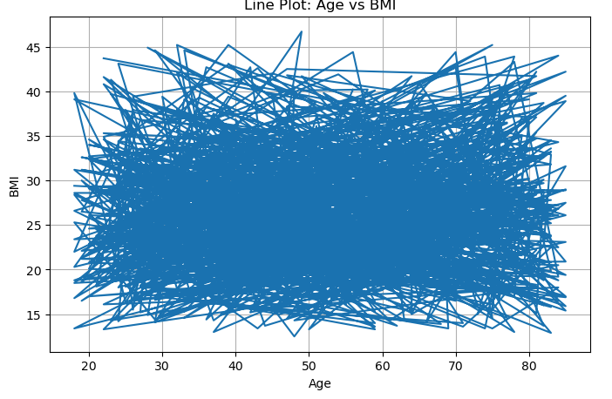
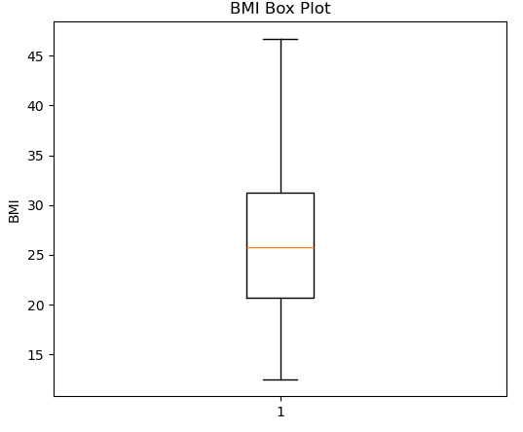
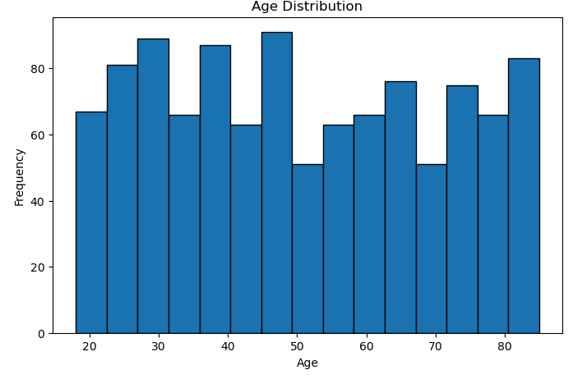
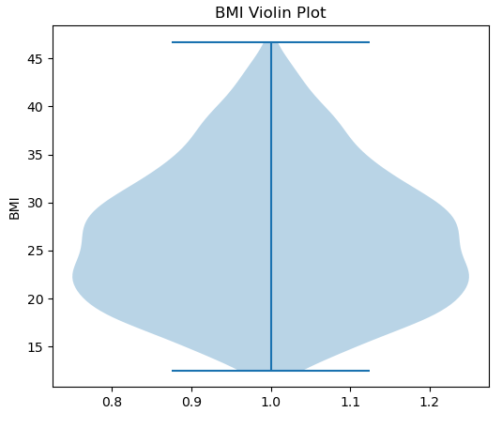
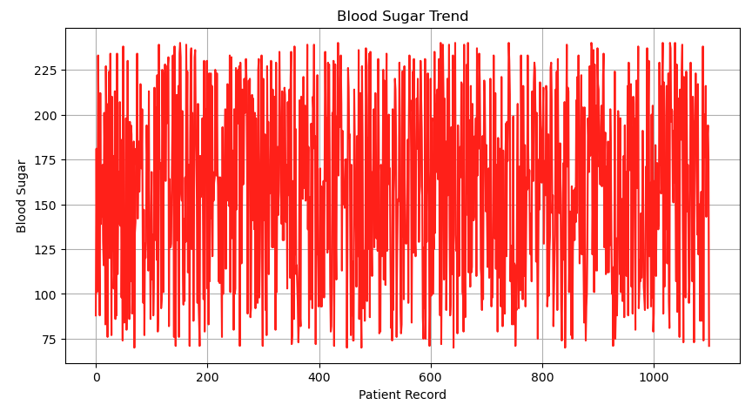
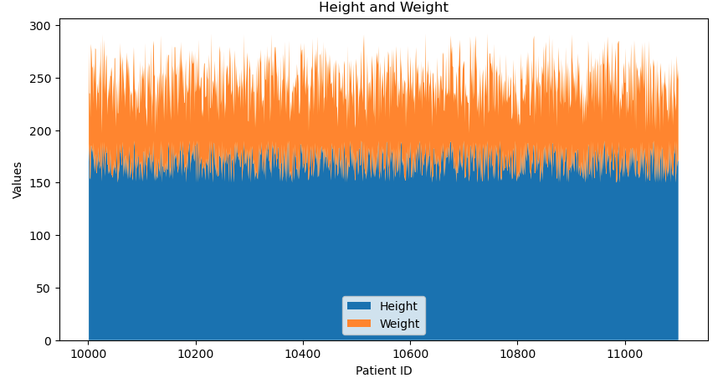
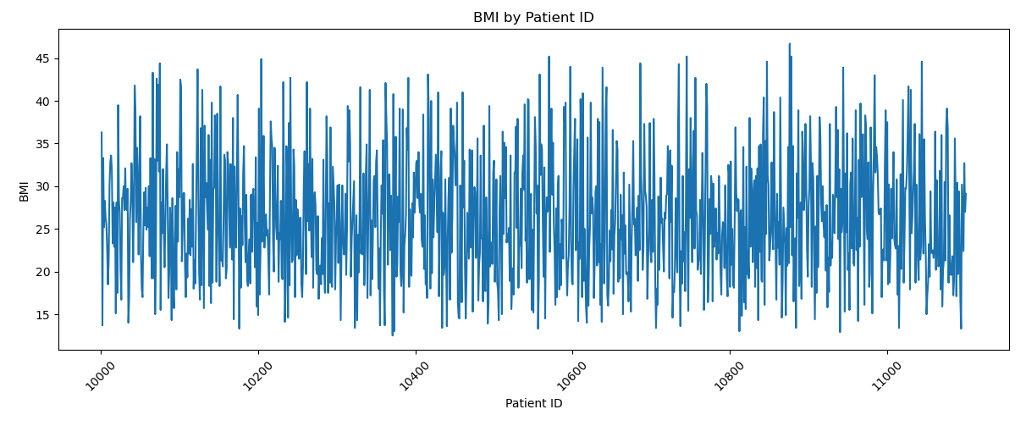
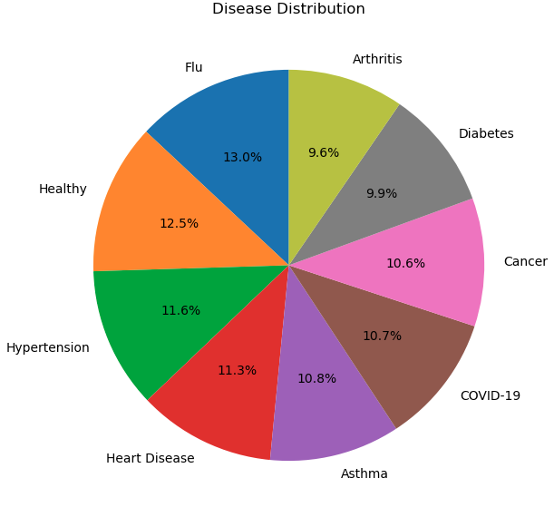
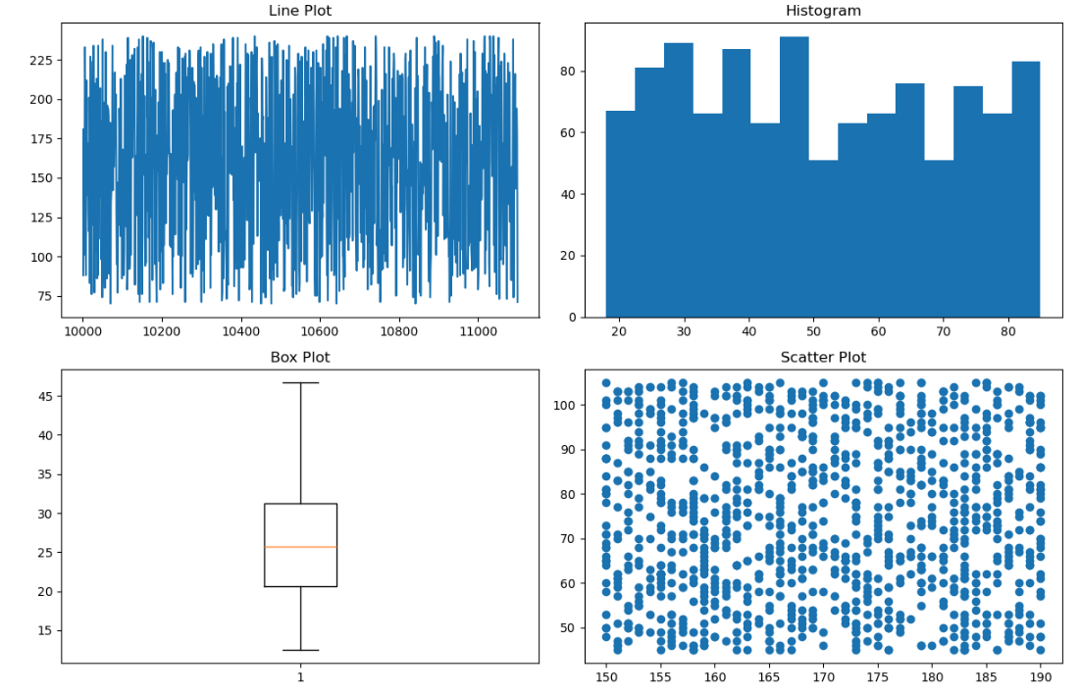
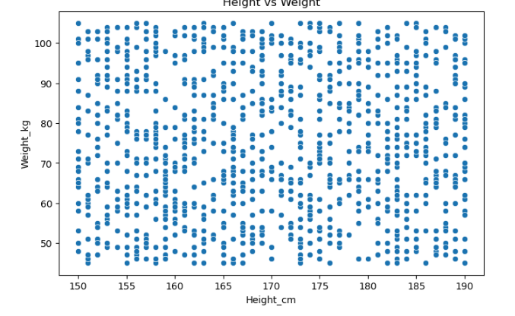
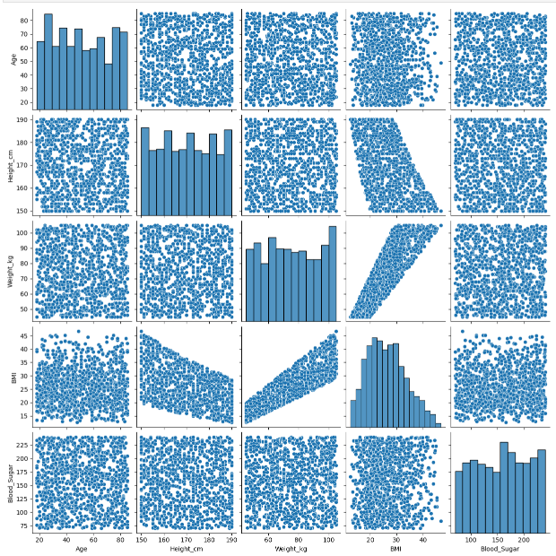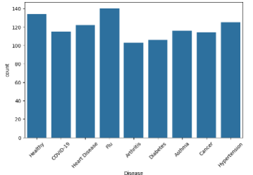

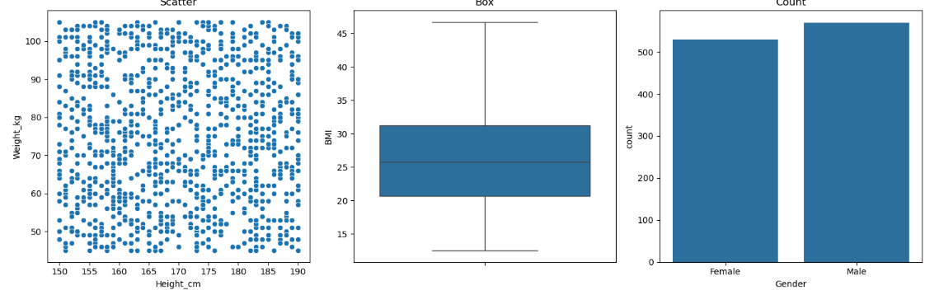

Result:

